Vehicle Parking App – V1

Author
Name: Aakash Sharma
Roll Number: 24f2003480
Student Email: 24f2003480@ds.study.iitm.ac.in
I am a Computer Science Engineering student at Jabalpur Engineering College and currently pursuing a B.S. in Data Science and Applications from IIT Madras. I have a strong interest in python development, artificial intelligence, and building real-world software systems using clean code and open-source tools.

Description
This project is about building a multi-user web application that manages vehicle parking lots, spot bookings, and billing. It includes role-based features for admin and regular users.
ChatGPT is also used to guide code structure, debug errors, and clarify architectural and database design decisions.

Technologies Used
- Flask – Backend web framework
- SQLAlchemy – ORM for SQLite database
- Jinja2 – Templating engine for rendering dynamic HTML
- HTML5, CSS3 – Frontend structure and styling
- Bootstrap 5 – For responsive layout and UI components
- Chart.js – For generating summary charts on dashboards

Architecture
Project Structure:
- app.py: Entry point and app initialization
- /models: SQLAlchemy models
- /routes: Flask Blueprints (auth, user, admin)
- /templates: Jinja2 HTML views
- /static: CSS and JS (chart.js)
- config.py: Environment and DB setup

DB Schema Diagram
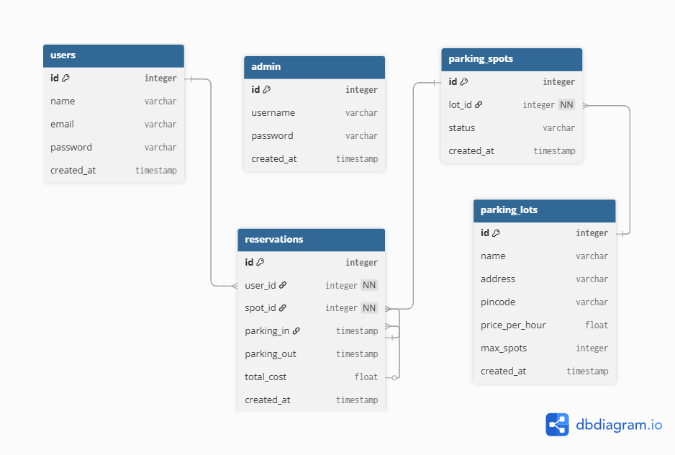

Features
- Admin default login
- Parking lot creation with auto-generated spots
- Real-time dashboard for spot status and bookings
- User registration/login and automatic spot booking
- Timestamp-based billing and parking history
- Analytics charts using Chart.js

Video
https://drive.google.com/file/d/1MNZNxMXwNo4WP4UB0CsxlZzMVfBq_d1L/view?usp=drive_link

